Iteration 3

CIS 320-02

Team: BusinessFirst

**Alexander Welsh, Dalton Karl, Anthony Striepe, Jrew Simpson, La’Daysha Wade**

Table of Contents

Table of Contents 2

System Requirements 4

Use Cases 6

Trace Matrix 11

Trace Matrix Narrative 11

Use Case Diagrams 12

Use Case 1-5 Diagram Music Showcase 12

Use Case 1-5 Diagram Narrative 12

Use Case 6-7 Diagram Program/Workshop Info Management Group 13

Use Case 6-7 Diagram Narrative 13

Use Case 8-9 Diagram Contact Form Group 14

Use Case 8-9 Diagram Narrative 14

Use Case 10-11 Contact Form 15

Use Case 10-11 Contact Form Narrative 15

Use Case 12-16 Diagram Donation Process 16

Use Case 12-16 Diagram Narrative 16

Use Case 17-18 Diagram Review System 17

Use Case 17-18 Diagram Narrative 17

Use Case 19-20 Diagram Social Media Integration System 18

Use Case 19-20 Diagram Narrative 18

Use Case 21-22 Diagram Sponsors Showcase 19

Use Case 21-22 Diagram Narrative 19

Use Case 23-24 Diagram Mission Statement 20

Use Case 23-24 Diagram Narrative 20

Use Case 25-27 Diagram 21

Use Case 25-27 Diagram Narrative 21

Use Case 28-31 Diagram 22

Use Case 28-31 Diagram Narrative 22

Use Case 32 & 34 Diagram Website Interface: 23

Use Case 32 & 34 Diagram Narrative 23

Use Case 33 Diagram Update Volunteer Hours 24

Use Case 33 Diagram Narrative 24

Gantt Chart 25

Use Case Work Breakdown 25

Prototypes 26

Song Catalog 26

Donation Page 26

Donation System 27

Newsletter Signup Dropdown 28

Hours Worked 29

Reviews Section 29

Social Media Integration 29

Sponsors Showcase 30

View Program/Workshop Information 31

Modify Program/Workshop Information/View Calendar 32

Interacts With Calendar 33

Fill Out Contacts 34

Modify Contact Form 35

View Contact Submissions 36

# System Requirements

**Functional Requirements**  
Event Calendar

ID: SR001 – The event calendar will display upcoming events.

ID: SR002 – The event calendar will display volunteer opportunities.

ID: SR003 – The event calendar will allow users to RSVP.

ID: SR004 – The event calendar will send users event reminders.

Volunteer Sign-Up

ID: SR005 – The volunteer sign-up will facilitate the process for users to register.

ID: SR006 – The volunteer sign-up will automatically confirm registrations.

Mobile Optimization

ID: SR007 – The mobile optimization will have a responsive design for mobile users.

ID: SR008 – The mobile optimization will maintain useability without sacrificing functionality.

Content Management System

ID: SR009 – The content management system will empower staff to easily update blogs.

ID: SR010 – The content management system will empower staff to easily update events.

ID: SR011 – The content management system will empower staff to easily update project reports.

ID: SR012 – The content management system will require no technical expertise.

Project Showcase

ID: SR013 – The project showcase will highlight current projects.

ID: SR014 – The project showcase will highlight completed projects.

ID: SR015 – The project showcase will increase transparency.

ID: SR016 – The project showcase will increase community engagement.

Social Media Integration

ID: SR017 – The social media integration will integrate social media links.

ID: SR018 – The social media integration will integrate social media feeds.

ID: SR019 – The social media integration will improve engagement.

ID: SR020 – The social media integration will improve visibility.

Newsletter Sign-Up

ID: SR021 – The newsletter sign-up will provide users with the ability to subscribe to email updates.

ID: SR022 – The newsletter sign-up will ensure supporters are informed about the latest news.

ID: SR023 – The newsletter sign-up will ensure supporters are informed about the latest opportunities.

Donation integration

ID: SR024 – The donation integration will provide an ease-of-use donation platform.

ID: SR025 – The donation integration will provide a secure donation platform.

ID: SR026 – The donation integration will allow one-time donations.

ID: SR027 – The donation integration will allow recurring donations.

ID: SR028 – The donation integration will be integrated with PayPal.

Song Catalog

ID: SR029 – The song catalog will list a number of songs made by youth participants.

ID: SR030 – The song catalog will have pause/play functionality.

ID: SR031 – The song catalog will have a volume slider.

ID: SR032 – The song catalog will have a share button for each song

Contact Form

ID: SR033 – The contact form will provide a simple outlet for questions

ID: SR034 – The contact form will increase community engagement

ID: SR035 – The contact form will provide opportunities for sponsors or partners to reach out

ID: SR036 – The contact form will have the option for submission to be viewed via email or Wix dashboard

**Non-Functional Requirements**

Sponsor Banner

ID: SR037 – The sponsor banner will show all organizations that have chosen to sponsor.

Reviews Section

ID: SR038 – The review section will show testimonies from youth participants and parents regarding their experiences with Worth the Words

Volunteer Hours Display

ID: SR039 – The volunteer hours widget will display the number of volunteer hours worked by Worth the Words volunteers

# Use Cases

**Use Case 1:** View Song Catalog  
Primary Actor: User  
Description: User can view the song catalog listed on the website  
Risk Level: Low

**Use Case 2:** Listen To Songs  
Primary Actor: User  
Description: User can click on different songs made by youth artists from the organization  
Risk Level: Low

**Use Case 3:** Manage Song Catalog  
Primary Actor: Admin  
Description: Admin can add or remove songs from the song catalog  
Risk Level: High

**Use Case 4:** Change Song Volume  
Primary Actor: User  
Description: User can use the volume slider to change the volume of the current song being played  
Risk Level: Low

**Use Case 5:** Share a Listed Song  
Primary Actor: User  
Description: User can click a button to share a song via social media  
Risk Level: Low

**Use Case 6:** View Program/Workshop Info  
Primary Actor: User  
Description: Curious users can view the information regarding provided programs and workshops   
Risk Level: Low

**Use Case 7:** Modify Program/Workshop Info  
Primary Actor: Admin  
Description: Admin can modify the information regarding the programs and workshops provided  
Risk Level: High

**Use Case 8:** Modify Layout/Fields of Contact Form  
Primary Actor: Admin  
Description: Admin has capability of modifying the layout of the contact form if necessary  
Risk Level: High (Contact form is critical to the system)

**Use Case 9:** Fill out fields in contact form  
Primary Actor: User  
Description: Users can fill out information in the contact form prior to clicking the submit button  
Risk Level: Low  
  
**Use Case 10:** Submit Contact Form  
Primary Actor: User  
Description: If the user has already filled out the fields in the contact form and ready to contact Worth the Words, they may click the submit button  
Risk Level: Low

**Use Case 11:** Read Contact Form Submissions  
Primary Actor: Admin  
Description: After users submit their contact forms, the admin can read the submissions.  
Risk Level: High (Could possibly contain sensitive data)

**Use Case 12:** Check/Uncheck Recurring Donation Box  
Primary Actor: User  
Description: Prior to submitting their donation, a user can make the donation recurring.  
Risk Level: High (Want to make sure the box is unchecked by default)

**Use Case 13:** Donate with PayPal  
Primary Actor: User  
Description: Users clicks option of donating with their PayPal account  
Risk Level: High (Data security)

**Use Case 14:** Donate with Debit or Credit Card  
Primary Actor: User  
Description: Users clicks option of donating with Debit or credit card.  
Risk Level: High (Data security)

**Use Case 15:** Donation Submit Button  
Primary Actor: User  
Description: After users fill out their donation information, they click the submit button  
Risk Level: High (Data security)

**Use Case 16:** Accept Donations  
Primary Actor: Admin  
Description: Administrator accepts the donation from PayPal's PMS  
Risk Level: High (Data security)

**Use Case 17:** Change Reviews  
Primary Actor: Admin  
Description: Administrator makes changes to the reviews  
Risk Level: High

**Use Case 18:** View Reviews  
Primary Actor: User  
Description: User views the reviews  
Risk Level: Low

**Use Case 19:** View Social Media  
Primary Actor: User  
Description: User views the integrated social media posts

Risk Level: Low

**Use Case 20:** Social Media Connection  
Primary Actor: Admin  
Description: Administrator connects a social media post to the website  
Risk Level: Low

**Use Case 21:** View Sponsors  
Primary Actor: User  
Description: User views the organizations that are sponsoring  
Risk Level: Low

**Use Case 22:** Update Sponsors  
Primary Actor: Admin  
Description: Administrator updates the organizations that are sponsoring  
Risk Level: Low

**Use Case 23:** View Mission Statement  
Primary Actor: User  
Description: User views the mission statement  
Risk Level: Low

**Use Case 24:** Update Mission Statement  
Primary Actor: Admin  
Description: Admin makes changes to the mission statement  
Risk Level: High

**Use Case 25:** View Application Page  
Primary Actor: User  
Description: User views the application page  
Risk Level: Low

**Use Case 26:** Filling Out Application  
Primary Actor: User  
Description: Users fills out an application  
Risk Level: Low

**Use Case 27:** Review Applications  
Primary Actor: Admin  
Description: Admin reviews the application and chooses to accept of decline the volunteer  
Risk Level: High (Volunteers must be vetted)

**Use Case 28:** View Calendar  
Primary Actor: User  
Description: User views the future events on the calendar  
Risk Level: Low

**Use Case 29:** Interacts With Calendar  
Primary Actor: User  
Description: User clicks events on the calendar which displays information related to the event  
Risk Level: Low

**Use Case 30:** Clicks RSVP on Calendar  
Primary Actor: User  
Description: User clicks the option to RSVP on the calendar  
Risk Level: High (RSVP would take a user’s email or phone number as input, data security concern)

**Use Case 31:** Makes Changes to Calendar  
Primary Actor: Admin  
Description: Admin makes changes to events on the calendar  
Risk Level: High

**Use Case 32:** View Volunteer Hours   
Primary Actor: User  
Description: User views displayed volunteer hours  
Risk Level: Low

**Use Case 33:** Update Volunteer Hours Display  
Primary Actor: Admin  
Description: Admin updates the amount of volunteer hours worked.  
Risk Level: High

**Use Case 34:** Newsletter Signup Button  
Primary Actor: User  
Description: User inputs their email and signs up for the newsletter  
Risk Level: High (Data security for email)

# Trace Matrix

* [**Trace Matrix Excel Sheet**](https://cardmaillouisville-my.sharepoint.com/:x:/g/personal/alstri02_louisville_edu/EfX6JeEe1ElGkNao6RGy220BSNmd0InLjciUv5RMF5FT6A?e=EXGYBr)

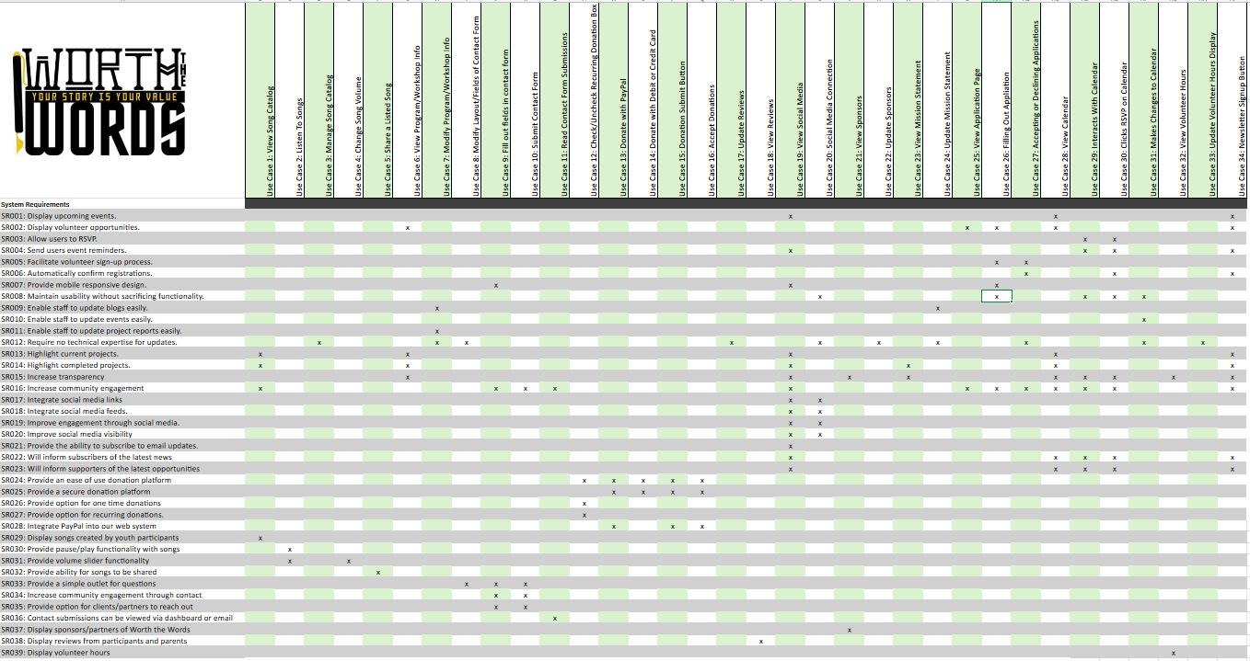

## Trace Matrix Narrative

Our trace matrix serves the purpose of matching our use cases with the requirements that each one fulfills. We have system requirements on the left-hand side each with a unique identifier (SR0##) and use cases on the top that also have unique identifiers (Use Case #). Due to certain use cases fulfilling multiple requirements, we have use cases that fulfill similar requirements of others. Some examples include viewing social media, joining the newsletter, and interacting with the calendar use cases fulfilling the system requirement of increasing community engagement. Our system requirements and use cases were designed with the primary purpose of developing a system that is focused on improving end user experience, building engagement, and increasing monetary funding. If scope creep were to occur, system requirements and use cases are easily added, removed, or updated in the excel sheet that the trace matrix is stored in.

# Use Case Diagrams

## Use Case 1-5 Diagram Music Showcase

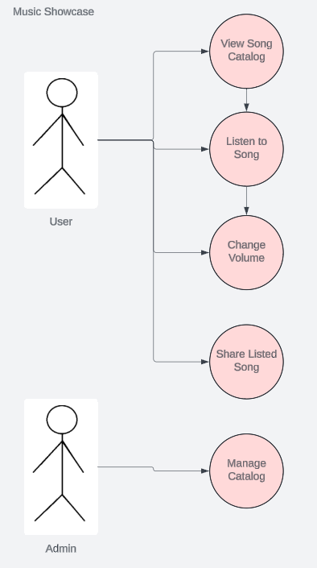

## Use Case 1-5 Diagram Narrative

The user must scroll down the home page to view the song catalog. The user can then hit play to hear the first music option on the track. The user can also change the volume of the music that is playing with a volume slider. If the user likes the song, they can click the share button which will allow them to post it on their social media to share it with other people. An administrator’s job is to update the song catalog by adding, replacing, or removing songs from the catalog.

## Use Case 6-7 Diagram Program/Workshop Info Management Group

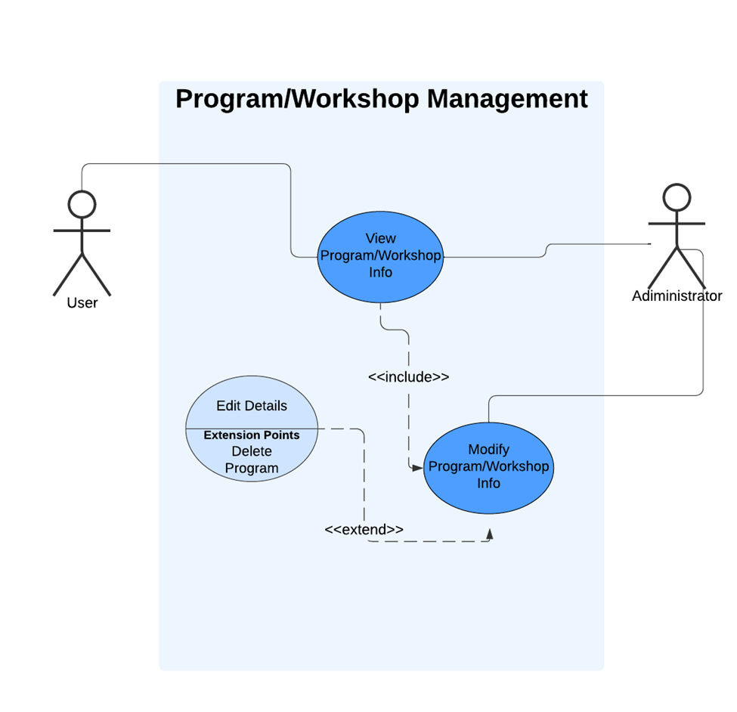

## Use Case 6-7 Diagram Narrative

The Program/Workshop Management system provides users with the ability to view information about various programs and workshops, enabling them to stay informed about available options. Administrators have enhanced access, allowing them not only to view but also to modify program and workshop details, ensuring that information remains accurate and up-to-date. Through an extension point labeled "Edit Details," administrators can make specific changes, such as updating or reordering content, while also having the option to delete programs when necessary. This setup distinguishes user and administrator roles, providing users with straightforward access to information while empowering administrators to manage and maintain program data efficiently.

## Use Case 8-9 Diagram Contact Form Group

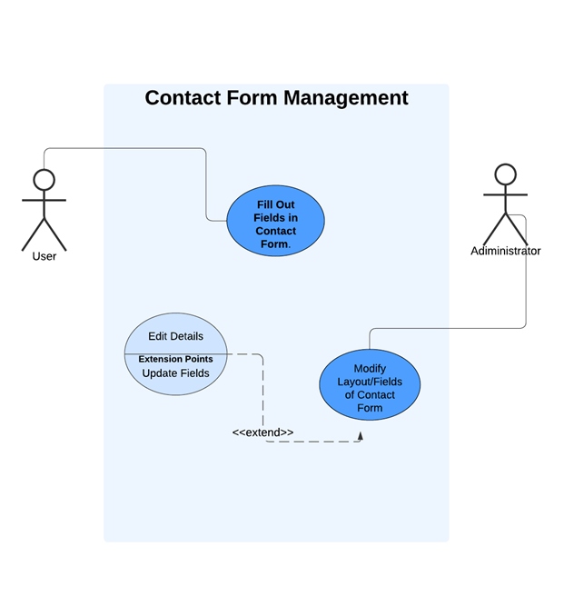

## Use Case 8-9 Diagram Narrative

The Contact Form Management system allows users to fill out fields in the contact form, enabling them to communicate with the organization. Administrators have additional access to modify the form's layout and fields, ensuring it aligns with organizational needs. Through an extension point labeled Update Fields, administrators can make detailed adjustments, like editing or reordering fields, keeping the form adaptable and relevant. This setup highlights the difference in user and administrator permissions, ensuring both accessibility for users and flexibility for administrators in managing contact form details.

## Use Case 10-11 Contact Form

## Use Case 10-11 Contact Form Narrative

The contact form system allows users to create and submit forms, which administrators can review later. First, the user fills out the contact form by entering details like their name, email, and message. Then, they submit the form, which is checked for errors and saved in the database. Administrators can log in to the system to read and manage these submissions. The ability to read submissions depends on the forms being successfully submitted. Submitting forms is low risk, but reviewing them can be higher risk since it might involve sensitive information. This system helps users and administrators communicate efficiently.

## Use Case 12-16 Diagram Donation Process

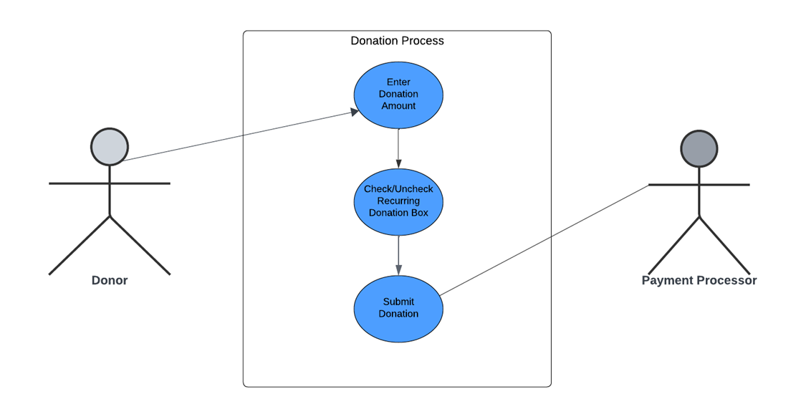

## Use Case 12-16 Diagram Narrative

This use case diagram shows how the donor interacts with the donation system. The donor can make a donation by selecting an amount, deciding whether the donation is one-time or recurring, and choosing a payment method (PayPal or credit card). The system then checks the details and processes the payment securely. The diagram illustrates the steps the donor goes through and how the system handles the donation process, ensuring everything works smoothly and securely. It helps explain the overall flow of the donation process without showing any behind-the-scenes management functions.

## Use Case 17-18 Diagram Review System

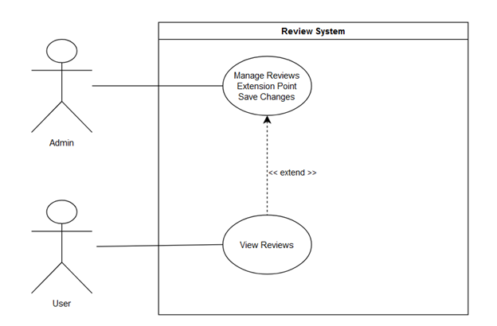

## Use Case 17-18 Diagram Narrative

The admin makes changes to the displayed reviews on the website from the Wix backend. The user viewing the updated reviews depends on the admin clicking the save button for the changes.

## Use Case 19-20 Diagram Social Media Integration System

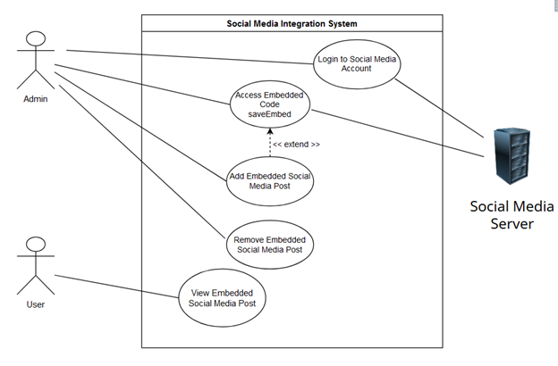

## Use Case 19-20 Diagram Narrative

The admin logs into the Social media account which requires a connection to the social media server. The admin then selects the desired social media post, clicks the share button and accesses the embed code. The admin then uses this code in the Wix backend and pastes the code to add the desired social media post. Removing the social media post or having a user view an embedded post does not require the actor to connect the social media server.

## 

## Use Case 21-22 Diagram Sponsors Showcase

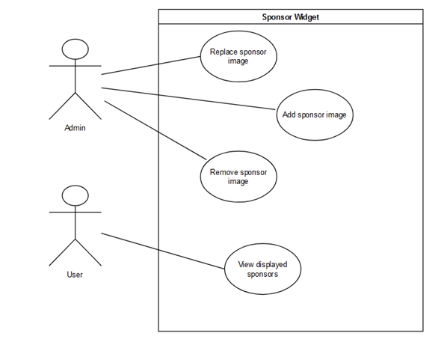

## Use Case 21-22 Diagram Narrative

The administrator can maintain the sponsor widget by either removing, adding, or replacing a sponsor’s image in the widget. The one use case for a user is viewing the displayed sponsors that the administrator displayed.

## Use Case 23-24 Diagram Mission Statement

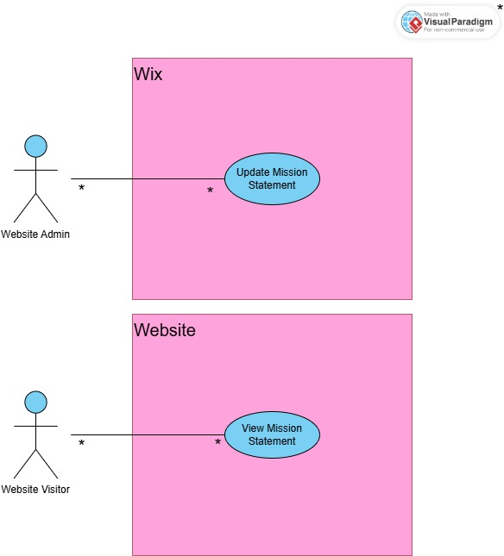

## Use Case 23-24 Diagram Narrative

The visitor is able to navigate to the Mission Statement via the “About” tab. This mission statement is the result of whatever the website admin inserts on the CMS side, which in this case is Wix. The mission statement is reflective of what the website puts in Wix at any given time.

## A diagram of a website Description automatically generatedUse Case 25-27 Diagram

## Use Case 25-27 Diagram Narrative

Visitors who express interest in volunteering for events can access the sign-up form via the “Get Involved” page. By clicking on the volunteer button, the visitor is taken to the application, which they will fill out with all the necessary information. When they have filled it out, they then hit submit, where the website admin will receive it. These responses will be viewable from the CMS, and the admin will be able to either discard the application or follow up with the applicant via a method of communication provided.

## A diagram of a website Description automatically generatedUse Case 28-31 Diagram

## Use Case 28-31 Diagram Narrative

The visitor is able to view the calendar via the “Get Involved” page as well. All calendar updates are made within the website admin’s calendar of choice. After changing, adding, or deleting an event, it will show up on the website. From there, visitors can interact with events by clicking on them to have information tabs pop out. Inside these tabs will be all the relevant information for the event, as well as an RSVP button. Clicking this button will allow visitors to submit information, and have their name added to a list of participants that is visible to the admin.

## Use Case 32 & 34 Diagram Website Interface:

## Use Case 32 & 34 Diagram Narrative

In this use case diagram, the User interacts with the Worth the Words Website to perform two main functions: View Volunteer Hours and Newsletter Signup Button. When viewing volunteer hours, the User initiates an action to access their recorded hours contributed to the organization. The website system retrieves this data from the database and displays it, allowing the User to view their contributions. For the newsletter signup, the User clicks on the signup button, inputs their email, and submits it to subscribe to the organization's newsletter. The website system validates the email format and, upon successful validation, stores it in the database for future communications.

## Use Case 33 Diagram Update Volunteer Hours

## Use Case 33 Diagram Narrative

In this use case, the Admin interacts with the Worth the Words Website to Update Volunteer Hours. This interaction allows the Admin to input, modify, or correct the recorded hours contributed by volunteers, ensuring accurate and up-to-date records.

# A graph with green lines Description automatically generated with medium confidenceA screenshot of a computer Description automatically generatedGantt Chart

## Use Case Work Breakdown

Our group broke down our use cases based on groupings for the diagrams we needed to create. The groupings we came up with were “Song Management and Media”, “Programs, Workshops, and Contact”, “Donations, Financials, and Extra Tasks”, “Feedback, Reviews, and Sponsors”, “Scheduling and Applications”. This distribution allowed all of our members to more quickly and efficiently create diagrams that show a relationship between use cases rather than have multiple diagrams for cases in the same system. On paper some members had more use cases, but the workload was lessened because there were fewer individual diagrams. This allowed us to compose them into this iteration without having to add on to each other’s diagrams.

# Prototypes

## Song Catalog

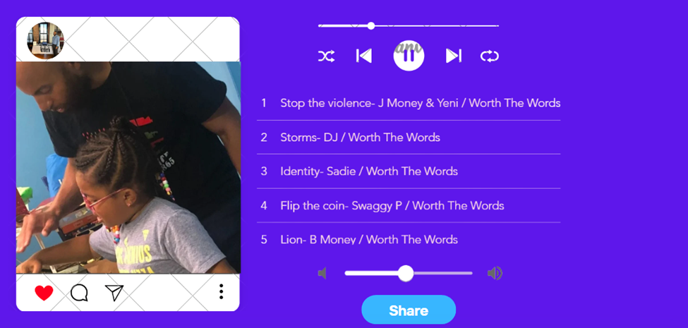

## Donation Page

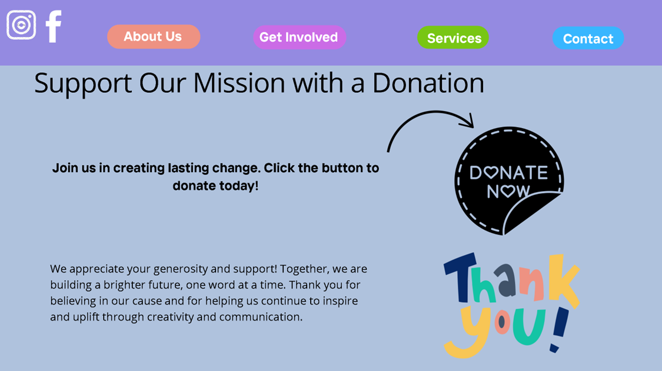

## Donation System

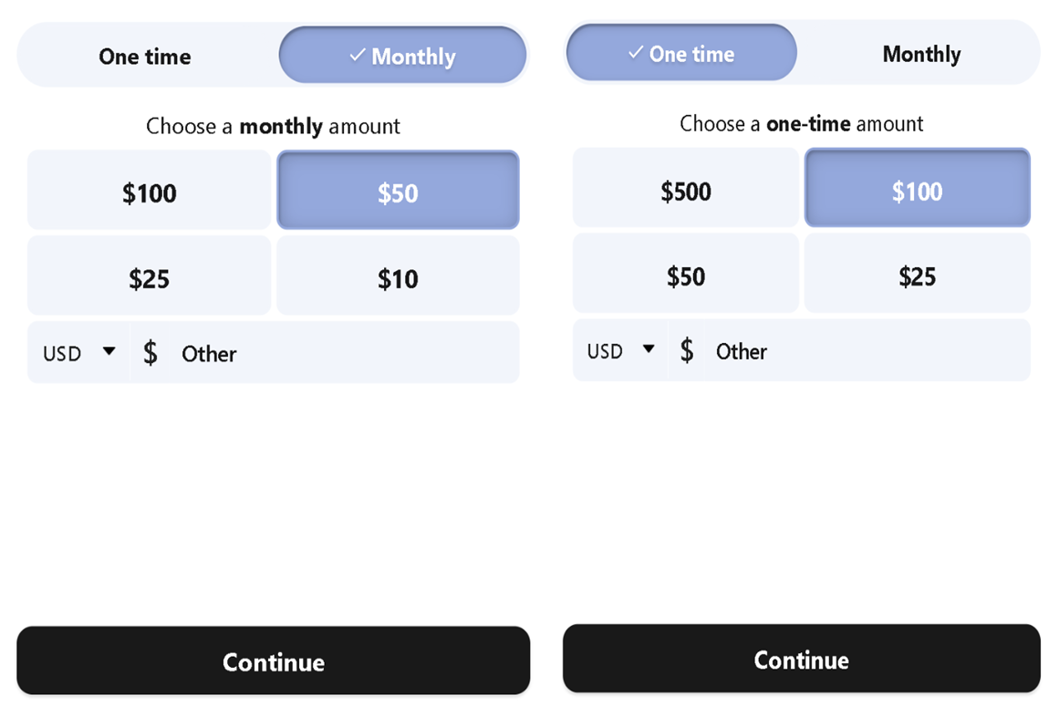

## Newsletter Signup Dropdown

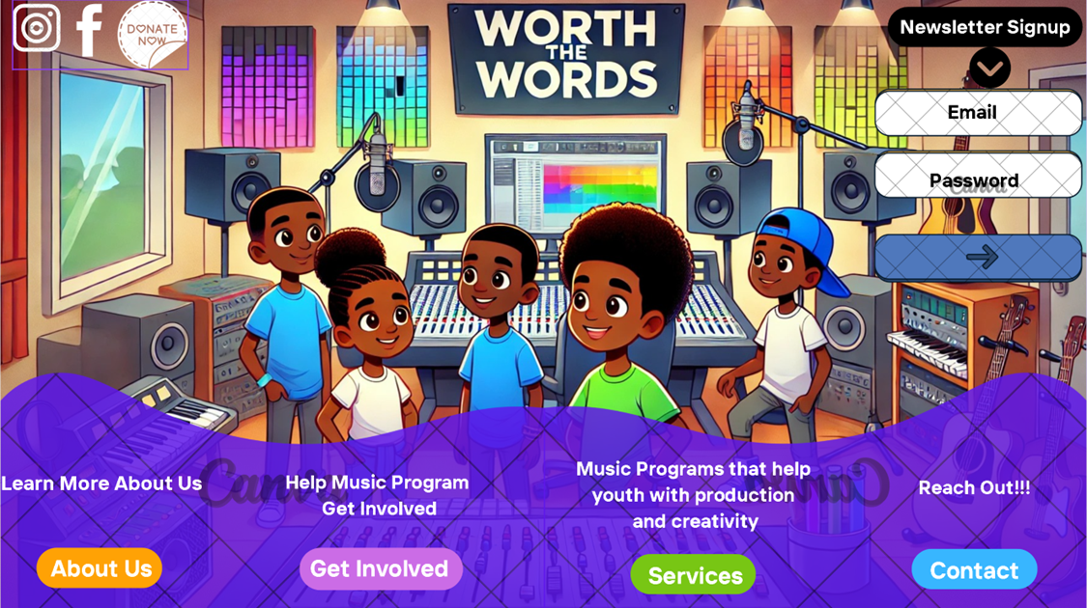

## Hours Worked

## Reviews Section

## Social Media Integration

## Sponsors Showcase

## A screenshot of a computer Description automatically generatedView Program/Workshop Information

## Modify Program/Workshop Information/View Calendar

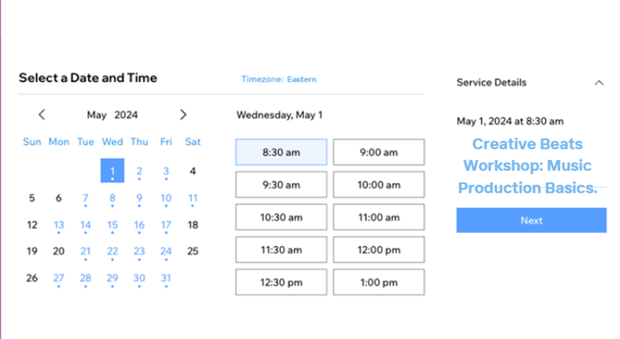

## A screenshot of a computer Description automatically generatedInteracts With Calendar

## Fill Out Contacts

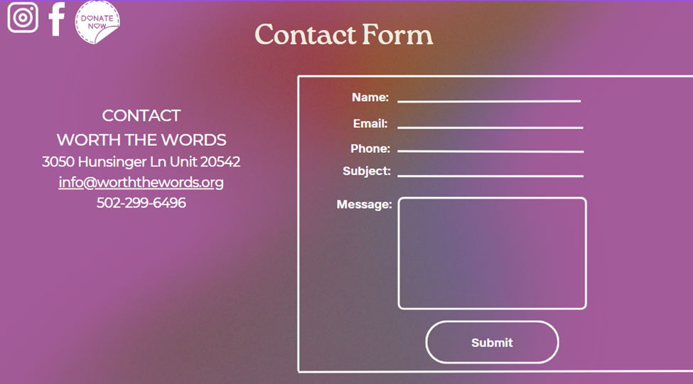

## Modify Contact Form

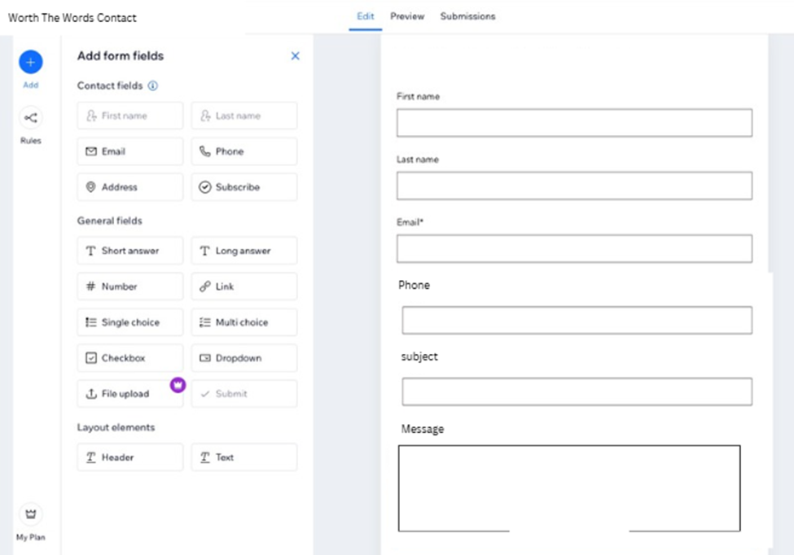

## View Contact Submissions

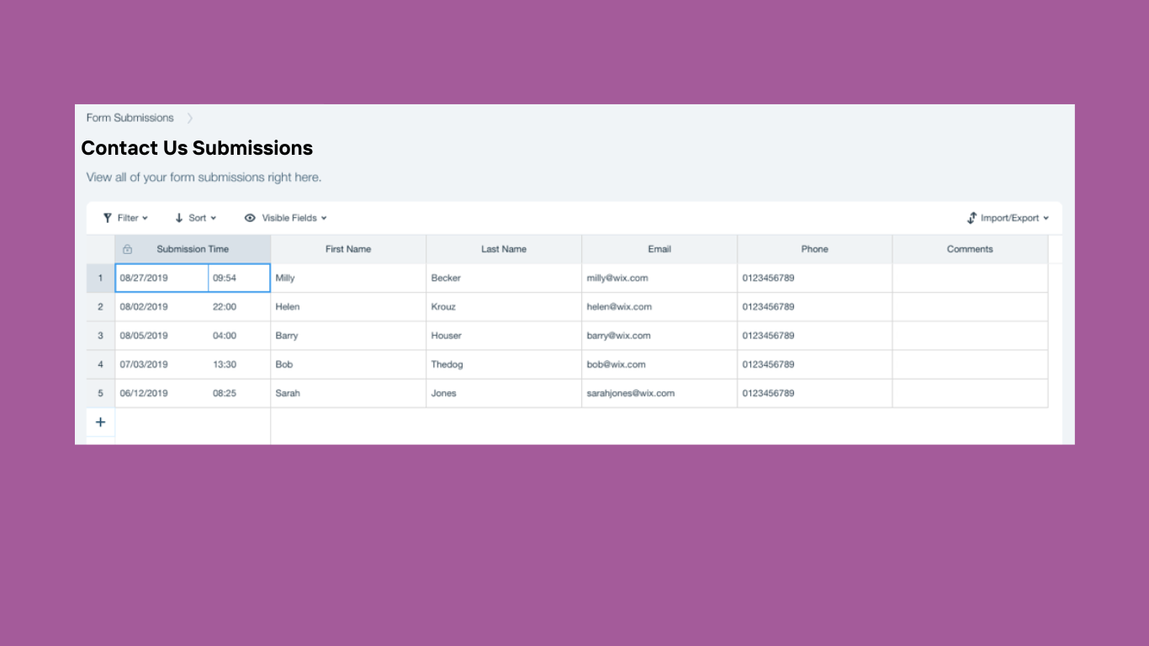

View Mission Statement

Filling out Volunteer Application